Row clause in sql

Row clause are used along with window function.

Syntax:

Select *,agg fn() over(partition by … order by …. <window frame>) from tbl.name

Here window frame includes rows

Type of row clause used

Unbounded preceding

N preceding

Current row

M following

Unbounded following

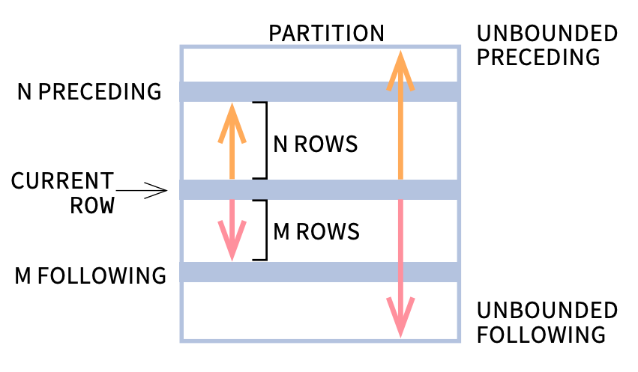

* **UNBOUNDED PRECEDING is the same as BETWEEN UNBOUNDED PRECEDING AND CURRENT ROW.**
* **n PRECEDING is the same as BETWEEN n PRECEDING AND CURRENT ROW.**
* **n FOLLOWING is the same as BETWEEN CURRENT ROW AND n FOLLOWING.**
* **UNBOUNDED FOLLOWING is the same as BETWEEN CURRENT ROW AND UNBOUNDED FOLLOWING.**

Real life example on the application of row clause

1. 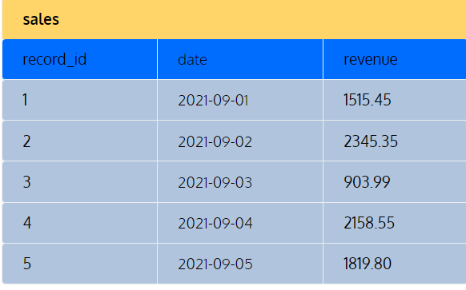

Lets used this table in postgresql

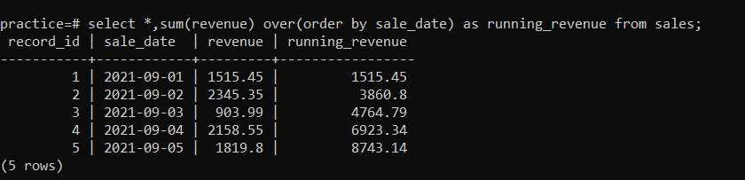

The above query is for total revenue upto the date .

1. 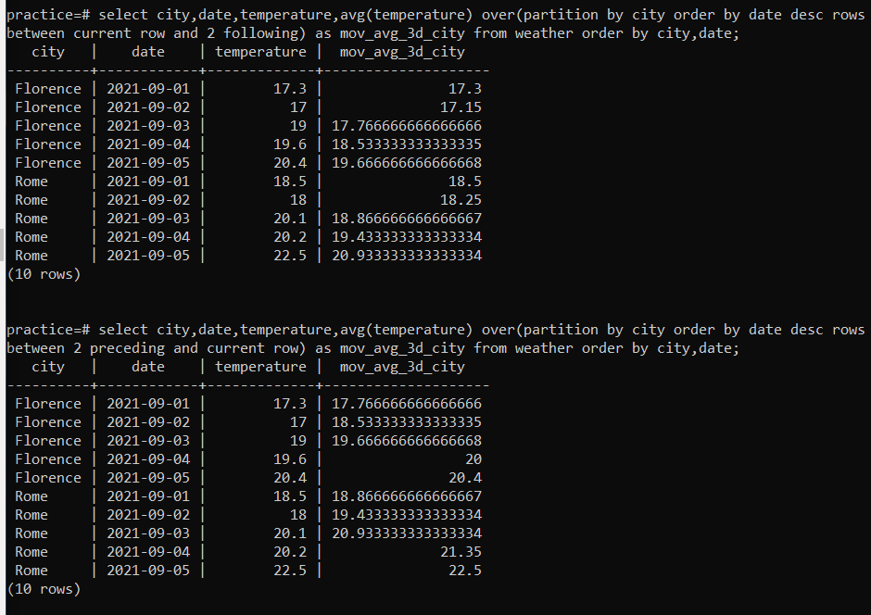

3. 